One perfect night. Forty years of buried hurt. One chance to make it right. Can the past ever be fixed?
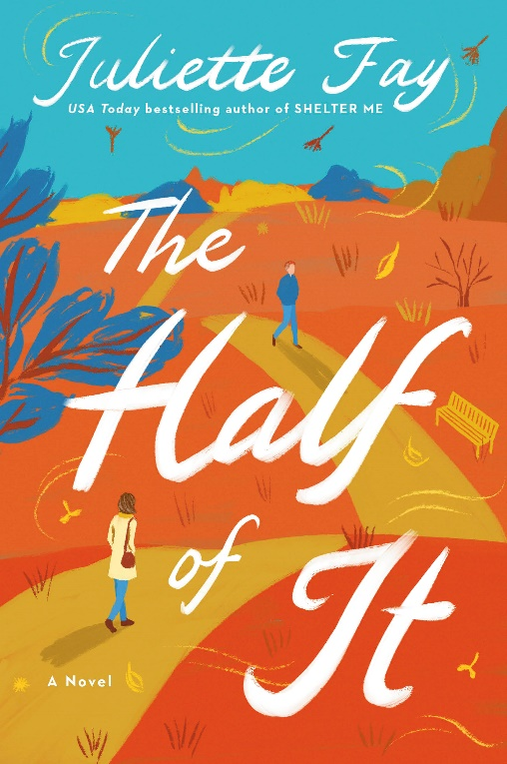
THE HALF OF IT
by Juliette Fay

April 11, 2023 / William Morrow
Paperback | $18.99
ISBN: 9780063235960
Audio ISBN: 9780063235984
E-book ISBN: 9780063235977

This April, USA Today bestselling author Juliette Fay returns with an emotional story of lost love and the ghosts of our past, perfect for fans of Jodi Picoult and Jojo Moyes. THE HALF OF IT is an emotional, introspective novel that begs the questions: Can the past ever really be fixed? And what would you do if you ran into the person who sent your life into a tailspin after forty years apart?

When fifty-eight-year-old Helen Spencer reviews her life, what she sees are the mistakes. Over the years, things seemed to go sideways incrementally, one little wrong decision at a time. She can even pinpoint where it all started to go awry: a wonderous, romantic night in the woods her senior year of high school with a boy named Cal Crosby. A night she works hard to forget.

Four decades, one marriage, three children, and one grandbaby later, suddenly there he is—Cal Crosby!—right in front of her with grandchildren of his own in tow. The chance to finally get some answers and sort out what happened between them is within reach. But Helen would much prefer to keep that night and all the fury, hurt, and sorrow that followed tightly locked away where she doesn’t have to face it. Cal Crosby, however, is ready to talk. He has no idea of the can of worms he’s about to open. In fact, he doesn’t know the half of it.

A warm, poignant, propulsive novel about settling the past, THE HALF OF IT is centered around rekindling lost friendships, coming to terms with hurt, and discovering love when you least expect it. And as a SheReads Best Book Club Pick of 2023, there’s no better choice for your next gathering.

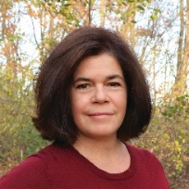
About the author: Juliette Fay is the award-winning, bestselling author of six previous novels, including Shelter Me, a Massachusetts Book Award finalist and Indie Next pick, and The Tumbling Turner Sisters, a USA Today bestseller. A graduate of Boston College and Harvard University, she lives in Massachusetts with her family.

Early praise for THE HALF OF IT:
“Best-seller Fay (Catch Us When We Fall) presents a touching story of friendship, love, and forgiveness with relatable characters managing the emotional challenges of daily life. Fans of Anna Quindlen who enjoy expressive stories of human connection will enjoy this novel.”
— Library Journal

“Fay’s characters come to life in all their flawed glory as they explore the road not taken and a second chance at righting the past. Once again, Fay delivers a highly satisfying read.”
— Lee Woodruff, New York Times bestselling author of In An Instant

“The Half of It is a warm and unconventional love story that considers what comes after marriages in which neither happily nor ever are quite in evidence. Instead, Juliette Fay gives us a heartfelt novel where hard-earned wisdom and long-awaited grace provide their own romance, passion, heartbreak, and, ultimately, hope.”
— Laurie Frankel, New York Times bestselling author of This is How it Always Is

“Imbued with her trademark warmth and wit, The Half of It by Juliette Fay is a gorgeously written stunner of a novel about family, love, grief, and ultimately, second chances. Fay is a master of creating characters who feel so real, their stories so emotionally resonant—I know that Helen and Cal and their families will linger in my heart long after I turned the last page.”
— Jillian Cantor, USA Today bestselling author of Beautiful Little Fools

“This is a heartfelt and funny second-chance romance story that has a great big heart and a complex and interesting protagonist. Love in this book comes in so many shapes, ages and sizes, leading up to a surprising ending that had me in my feelings. You think it’s too late to find love? Well, you don’t know The Half of It.”
— Catherine McKenzie, USA Today bestselling author of Forgotten and Hidden

“The Half of It is, simply put, a dose of beauty. Fay invites you into a story where you feel so at home, you don't want it to end. I'm a longtime fan of Fay's work, and it's no exaggeration to say I enjoyed every word of The Half of It.”
— Jessica Strawser, bestselling author of the The Next Thing You Know

For a complete list of Juliette’s events, visit http://juliettefay.com/events/.

